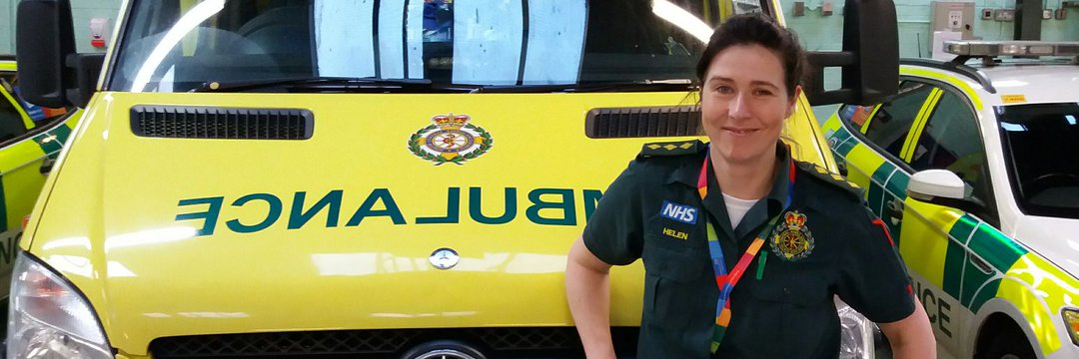
Dear All,

Are you interested in improving care of people with dementia who need emergency care? If so, we’d like to invite you to work with us!

We are a team of paramedics, data analysts and health service researchers from South Central Ambulance Service Trust and the Universities of Portsmouth and Southampton. We are working to improve the information recorded in our systems, for people with dementia, who have a face to face ambulance response. We also want to improve how we communicate this on to other services such as the staff in A&E or social care.
In our previous work with paramedics, patients and the public, we have created a section on the electronic patient record which enables ambulance staff record whether or not the person they are attending to has a diagnosis of dementia, or is suspected to have dementia. We are now testing to see how this new ‘dementia tab’ section is being used in practice.
We would like to form a group of people who have experience of dementia as a patient, carer or relative, or in a role such as community support, to work with us. This would involve attending some discussions held online to talk about what we have done so far, help us describe and interpret the effects of having a dementia section on the ambulance patient record, and think about what this means for patient care and what more needs to be done.

We cordially invite you to an online session lasting approximately 45 minutes at one of the times listed below:
Tuesday 6th December 2pm:
Join on your computer, mobile app or room device
Click here to join the meeting
Meeting ID: 363 692 928 206
Passcode: ez9X8h
Download Teams | Join on the web

Tuesday 13th December 5pm:
Join on your computer, mobile app or room device
Click here to join the meeting
Meeting ID: 376 807 726 381
Passcode: yjFrMv
Download Teams | Join on the web

Please get in touch with Carole Fogg (c.l.fogg@soton.ac.uk) if you have any questions in advance of the meeting.
Hope to see you there!
